**1.** **SVM Classification**

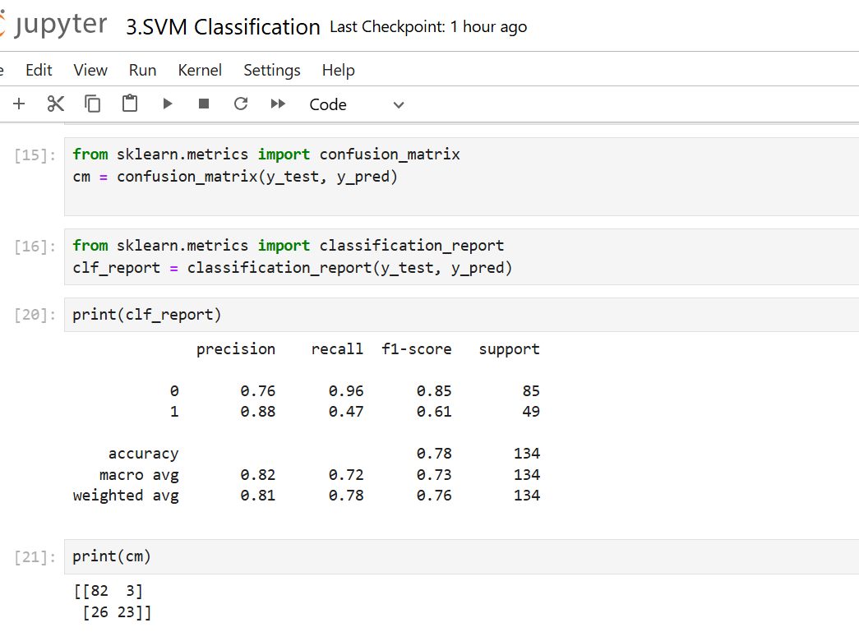

**Precision**: How many of the predicted positive cases for not purchase were actually positive?

* Class 0: 0.76

**Precision**: How many of the predicted positive cases for purchase were actually positive?

* Class 1: 0.88

**Recall**: how many of the actual positive cases for not purchase were correctly predicted?

* Class 0: 0.96

**Recall**: how many of the actual positive cases for purchase were correctly predicted?

* Class 1: 0.47

**F1-Score**: what is the harmonic mean of precision and recall for not purchased?

* Class 0: 0.85

**F1-Score**: what is the harmonic mean of precision and recall for purchased?

* Class 1: 0.61

**Accuracy**:What is the overall accuracy?

78%

**Support**: what is the number of actual occurrences of each class in the dataset for not purchased?

* Class 0: 85

**Support**: what is the number of actual occurrences of each class in the dataset for not purchased?

* Class 1: 49

**Support**: What is the Total support for all class in the dataset? 134

**Macro Average**: what is the arithmetic mean of precision across both classes?

0.82

**Macro Average**: what is the arithmetic mean of recall across both classes?

0.72

**Macro Average**: what is the arithmetic mean of F1-score across both classes?

0.73

**Weighted Average**: What is the weighted average for precision?

0.81

**Weighted Average**: What is the weighted average for recall?

0.78

**Weighted Average**: What is the weighted average for F1-score?

0.76